An Extraordinary Journey of Kinsan Chung’s Fine Art Pursuit
鍾建新的藝術旅程

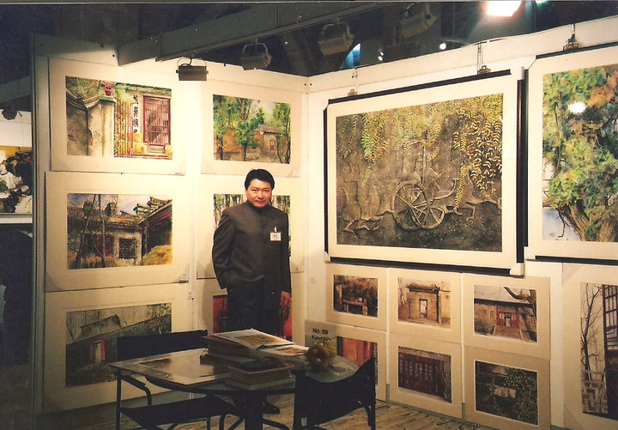

Written by
Iris Mu, Presenter & Research Writer
English translation by
Vincent LEE Kwun-leung, Art Officer & Fine Artist
Art Of Nature International Company Limited
11 January 2012

Kinsan Chung was born in New Territories, Hong Kong. He is a son of a farmer. He got to be sophisticated in life drawing since his 3-year-old age, and he portrayed his father’s Morris private car. At that time, he drew on the floor with chalks at his home. Even though his parents needed to mop the floor every day, they still felt grateful with his son’s artistic talents. During his capacity as a primary-school student, Kinsan Chung always cried because he bore up with a heavy workload in school assignments, as he hasn’t got spare time to pursue drawing and painting. His father gave him a comfort and said, “Never mind at all, Kinsan. Let me help you draw and paint then.”

Inside the infant heart of Kinsan Chung, drawing and painting become an irresistible part of his entire life.

However, his family life was getting not to be as optimistic as the previous days. As his father hadn’t got enough money to employ a tutor for his son, he attempted to make a painting frame as a gift to Kinsan. This allowed Kinsan to pursue life drawing in natural regions. His father told him, “It is a suitable time for you to be an apprentice of this awesome Nature”. He believed that, the Nature could probably become an “aesthetic teacher” of his beloved son.

Kinsan Chung began to create a large amount of life drawings and paintings with forests and coasts as references. Later on, these fine-art creations were nominated by “Hong Kong Youth Painting Competition” as awarded pieces, and Kinsan Chung was given an opportunity to participate in an exhibition at Hong Kong City Hall. At that time, Kinsan Chung had a chance to connect with the renowned art collectors in Hong Kong Museum of Art. Then, Kinsan Chung began to think, “One day, I must have my paintings exhibited in this place.”

As the time went by, the bitterness of life and the difficulties of survival emerged in front of Kinsan Chung. During his capacity as a secondary-school student, he needed to sell noodles for his mother after lessons. But he still insisted to further his drawing and painting practices in the fine-art tutorial class every Saturday. He later obtained Grade A in the Art Examination of Hong Kong Certificate of Education Examination (HKCEE). Once he graduated from the secondary school, he sought for a suitable job with his art pieces as interview portfolios. Finally, he got a position as a Design Assistant. However, the low salary made him unable to afford his life expenses. To better afford the survival needs of his little brother and sister, Kinsan Chung chose to become a postman. Later on, he enrolled as a policeman. At the very beginning, Kinsan Chung thought that, he would re-pick his painting pursuit once he earned enough money. But, unexpectedly, he had no alternative choice due to the life restrictions.

Since then, Kinsan Chung’s “extraordinarily persistent” character began to unveil. He competed with the fate based on his individual capabilities. He made use of his freelanced time to pursue drawing and painting. He adopted all his incomes to his further studies on fine arts. He bought art-related reference books, practiced oil painting and studied English. One day, his supervisor asked him, “You have an opportunity to advance as a Police Superintendent, Kinsan Chung. But, you have to give up your painting pursuit. It is because, you have to spend lots of time preparing for your career promotion, and later on, you will be extremely busy.” Finally, Kinsan Chung chose to give up such a promotion chance. He replied, “I can’t give up painting indeed.” Up to now, as Kinsan Chung stated in his reminiscence, the experiences of being a policeman contributed lots of useful inspirations to his life attitude, which positively affected the stylistic approaches of his future fine-art pursuit.

Later on, his supervisor began to support Kinsan Chung for accomplishing his artistic ideal. He recommended Kinsan Chung to study at Hong Kong Polytechnic University and learn watercolor skills from Stephen Yau. Then, he furthered his studies in watercolor painting at the Extramural Department of The Chinese University of Hong Kong. He was deeply affected by Lau Yam-tung’s teaching methodology. During his capacity of maintaining the discipline in the boundary regions of Sha Tau Kok, Kinsan Chung made use of his freelanced period to create a bunch of landscape paintings. These paintings were later nominated as exhibits in “Hong Kong Contemporary Art Biennial Exhibition”. He said, while knowing that his pieces were nominated, the delightful and joy feelings were much more influential than receiving a news about his future career promotion in the Police strata. At that moment, he clearly knows that his choice is very correct.

In 1996, Kinsan Chung got married. Her wife is a trustworthy person who accompanies him to go for the same artistic aspiration.

At that time, Kinsan Chung’s pieces were merchandized inside the fine-art galleries, but he gained very few incomes. One day, his wife asked him whether he would be interested in establishing an individual fine-art gallery. Later on, they could genuinely open their own fine-art gallery in Hong Kong Arts Centre, and they named it as “Creative Art Gallery”. Her wife was responsible for the managerial affairs. During the initial stage of operation, they noticed that, the expenditures were so huge. By getting the verification from the Police Authority, Kinsan Chung was allowed to conduct more painting courses in his fine-art gallery, which helped subsidize his required expenses. Later on, they found a shop with a larger area and space for them to establish a new fine-art gallery. There was an increasing number of students who received painting tutorship from Kinsan Chung.

Kinsan Chung’s pieces were also valued by the purchasers. In 1995, Sir Christopher Pattern, Former Governor of Hong Kong, collected two watercolor paintings in Kinsan’s solo fine-art exhibition. In the same year, Kinsan’s piece, called “Living In The Tradition - 1992” became a permanent collection in Hong Kong Museum of Art. In 1996, Kinsan’s pieces were, again, nominated as an exhibit in “Hong Kong Contemporary Art Biennial Exhibition”. Thereafter, the Toronto Museum of Fine Arts and King Henri of Luxembourg collected his pieces respectively. Kinsan Chung began to work as part-time art instructor in different organizations and institutes, including Hong Kong Museum of Art, The Chinese University of Hong Kong and Hong Kong Ching Ying Institute of Visual Arts.

Everything seemed to be quite fine. However, during the outbreak of SARS in 2003, Kinsan Chung lost all of his students. He encountered the risk of closure due to the reduction of tourist flow. During the most difficult moment, an American purchased a watercolor painting. The money that he gained helped him overcome the toughest SARS period. Also in 2003, Kinsan’s father died, and it made him feel very sad. This drove him to create pieces, which reflected his depressions and delightfulness from the deepest side of his innermost being. He began to confirm his artistic faith, which was, “Internalism”. This school of thought implies that, artists should regard fine art as a product that projects both their innermost beings and their immortal souls among the widespread art lovers, as well as expressing the genuine psychology of the artists beyond virtual reality and realistic realm.

After the outbreak of SARS, Kinsan Chung hoped to relocate his fine-art gallery in a place with an even greater area. He found an 1800-shaku unit in Chinese Resources Building. Also, he began to hold exhibitions in overseas by making use of his private holidays. There was a remarkable experience, that he and his wife discovered a great variety of art-related ships while holding an exhibition in the United States. Kinsan was much inspired by these shops. After returning to Hong Kong, he hired a village house that allowed him to observe the coastal scenes. He established “Country Art Museum”. He and his wife painted numerous kinds of graphics onto the surface of the village house. Apart from holding painting exhibitions, they established a restaurant as well. During the initial stage of operation, their days were very tough. There were no chefs, and all the foods had to be cooked by Kinsan’s wife. But, to persist with their immortal fine-art aspiration, they endeavored to overcome all the difficult days without fears.

Up to 2007, the artistic footprints of Kinsan Chung could be found in every corner of this world, including Taiwan, the Philippines, Singapore, Canada, Japan, Macao, Mainland China, Korea, Spain, the United Kingdom and the United States. In the same year, Kinsan Chung retired from his police occupation based on the minimum age requirement. He could thus become an occupational painter. Now, his another independent “Kinsan Chung’s New Fine Arts Garden” is going to be established soon.

Reminiscing these unique experiences, Kinsan Chung said, “The pursuit on fine arts is always like that. If no one appreciates your efforts, even you abandoned your art pieces on the street; no one would pick them up for other purposes. The Government would not be willing to offer you any sorts of helping hands as well. The only thing I could do is to rely on myself. In different epochs, artists should make use of their creative minds to search for a method that help your artistic life persist in all circumstances. The most important point is that, I have to be confident with myself. I must remember a word, which is, Never Give Up.”

In all kinds of human lives, it is quite difficult if we pursue a life style that does not comprise any kinds of secular elements. No matter what difficulties we encountered, you will see that, all the persons who can accomplish their ideals must undergo these experiences.

“Go back and continue with your paintings. Don’t waste your time,” his mother told him before his death in May 2011.

鍾建新出生於香港新界，是一個農民的孩子，三歲時已經懂得實物寫生——父親的摩利士汽車。那時候，他就每天用粉筆在自己家裡的地板上畫畫，他的父母雖然每天都要為此拖地板，卻為兒子的藝術天分感到高興。小學的時候，功課太多，鍾建新時常會為此大哭，因為他覺得自己沒有時間畫畫了，他的父親便只好安慰他說，沒關係，我幫你畫。

在鍾建新幼小的心靈裏，畫畫便是自己不能分割的一部份。

但是，漸漸地，家裡的生活不再如以前，他的父親沒有錢為想要繼續深造的兒子聘請老師，就親自做了一個畫架送給鍾建新，讓他到大自然中去寫生，父親告訴他：「是時候，師承自然」，他相信或許大自然能夠成為兒子的美學老師。

鍾建新開始在山林間，大海旁大量寫生，後來這些作品在香港青少年繪畫比賽中取得名次，到香港大會堂展覽，那一次，鍾建新有機會見到了當時香港藝術館內收藏的名家作品，他便開始在心中默默的想，有一天，我也要將作品掛在這裡。

隨著時間的推移，人生的悲苦與生存的磨礪開始漸漸展開在鍾建新的面前。中學時候，他常常要在放學以後去幫助媽媽賣粉麵，但仍然堅持在星期六的時間里去美術進修班繼續學習，在香港會考美術科取得「A」級成績。中學畢業的時候，他拿著自己的習作去到處找工作，終於得到一份設計助理的職位。但是，微薄的收入無法應付生活的開支，爲了供養弟弟，妹妹上學，他選擇做了一名郵差，後來又做了警察。一開始他想，先賺錢，等家裡情況好些再去畫畫，但是，沒想到，生活沒有給他別的選擇。

這時候，鍾建新比起常人格外執著的性格開始顯現了，他開始憑藉一己之力與命運抗爭，不斷地利用業餘時間畫畫，將收入用來進修，買藝術書籍，畫油畫，讀英文。有一天，他的上司問他「鍾建新，你有機會升做督察，但是，你需要放棄畫畫，因為，升督察需要很多時間準備，以後你會很忙」。而鍾建新的選擇是放棄升職，他說，我不能不畫畫。回來鍾建新回憶說，當警察的經歷給了他很多生活體驗，對他的人生觀以及後來的作品風格都產生了重要的影響。

後來，上司也開始支持他做畫家，並推薦鍾建新進入香港理工大學，跟Stephen Yau學習水彩技法。後來他又到香港中文大學繼續進修水彩畫，得到劉欽棟的薰陶。在被派往沙頭角邊境警署駐守期間，他利用業餘時間創作了大量風景作品。這些作品後來入選了香港當代藝術雙年展，他說，當知道自己作品入選時的那種興奮和快樂的感覺，要遠遠大於知道自己將要晋升的消息。那一刻，他知道自己的選擇是正確的。

1996年他同太太結婚，從此他又多了一個與自己理想同行的人。

那時候，他的作品在畫廊中寄賣，自己得到的收入不多，有一天，太太同他講，不如我們自己開一間畫廊。之後，他們真的在香港藝術中心開設了自己的畫廊，命名為「鍾建新畫廊」 (Creative Art Gallery)，由太太打理。初次經營的他們發現，開銷非常大。鍾建新通過了警察局的批准，開始在畫廊中增加教授繪畫的課程，來補貼費用。後來，他們又為畫廊找到了更大面積的鋪位，學生越來越多。

他的作品也不乏買家。1995年，香港前總督彭定康在一次個展上收藏過鍾建新的兩幅作品。同年，作品「生活在舊制度裡裏 ---- 1992年」被香港藝術館永久收藏。1996年他的作品再次入選香港當代藝術雙年展。其後，多倫多藝術博物館和盧森堡國王都先後收藏了他的作品。鍾建新開始在不同機構院校擔任兼職導師，包括香港藝術館，香港中文大學和香港正形藝術學院。

一切都看上去很順利，但是，在接下來的2003年，SARS來了。那一年，鍾建新的學生全部沒有了，缺少遊客的畫廊也面臨倒閉，在最困難的時刻，一個美國人購買了他的一幅作品，這筆錢讓他撐過了SARS時期。也是2003年，鍾建新的父親去世，令他悲痛不已，這也使他的作品更加觸及心靈深處的悲喜，他開始確立自己的藝術信仰——「內在主義」，就是將藝術視為內心與靈魂的折射品，在虛擬與寫實之間表達藝術家的心境。

SARS過後，鍾建新想將畫廊搬到更大的地方，他在華潤大廈找到1800尺的位置繼續經營，同時開始利用私人假期去國外做展覽。有一次，他同太太到美國做展覽時，見到小鎮上有很多與藝術有關的各種小店，非常受啓發，回到香港之後，他們租下一棟有海景的村屋，成立「鄉村藝術館」。他同太太一起，在村屋的外牆上畫滿各種圖案，在舉行畫展的同時，開設餐廳。剛開始的日子非常艱難，沒有廚師，所有食物都由太太親自料理，但是，爲了他們的藝術之路能夠走下去，一切困難都被日復一日的努力克服了。

到了2007年，鍾建新和他作品的足跡已經遍佈世界各地，包括台灣、菲律賓、新加坡、加拿大、日本、澳門、中國、韓國、西班牙、英國和美國。 在同一年，鍾建新以最低年齡從警隊退休了，他終於成為了一名全職畫家。現在，他的獨立私人藝術館「鍾建新藝術園地」也即將落成。

回憶起自己的這些經歷，鍾建新說，做藝術就是這樣，在沒有人欣賞你的時候，就算將作品仍在街上，都不會有人去撿，政府更加不會幫你，唯有靠自己，在不同的年代里，藝術家都要去動腦筋，尋找令自己的藝術生命繼續存在的方法，最重要的是對自己有信心，要記得——永不放棄。

在人的一生中，要想不隨波逐流的生活，有多麼的艱難，但是，能夠實現理想的人都是這樣過來的。

他的媽媽在2011年5月去世前對他說：「回去畫畫吧，不要浪費時間。」

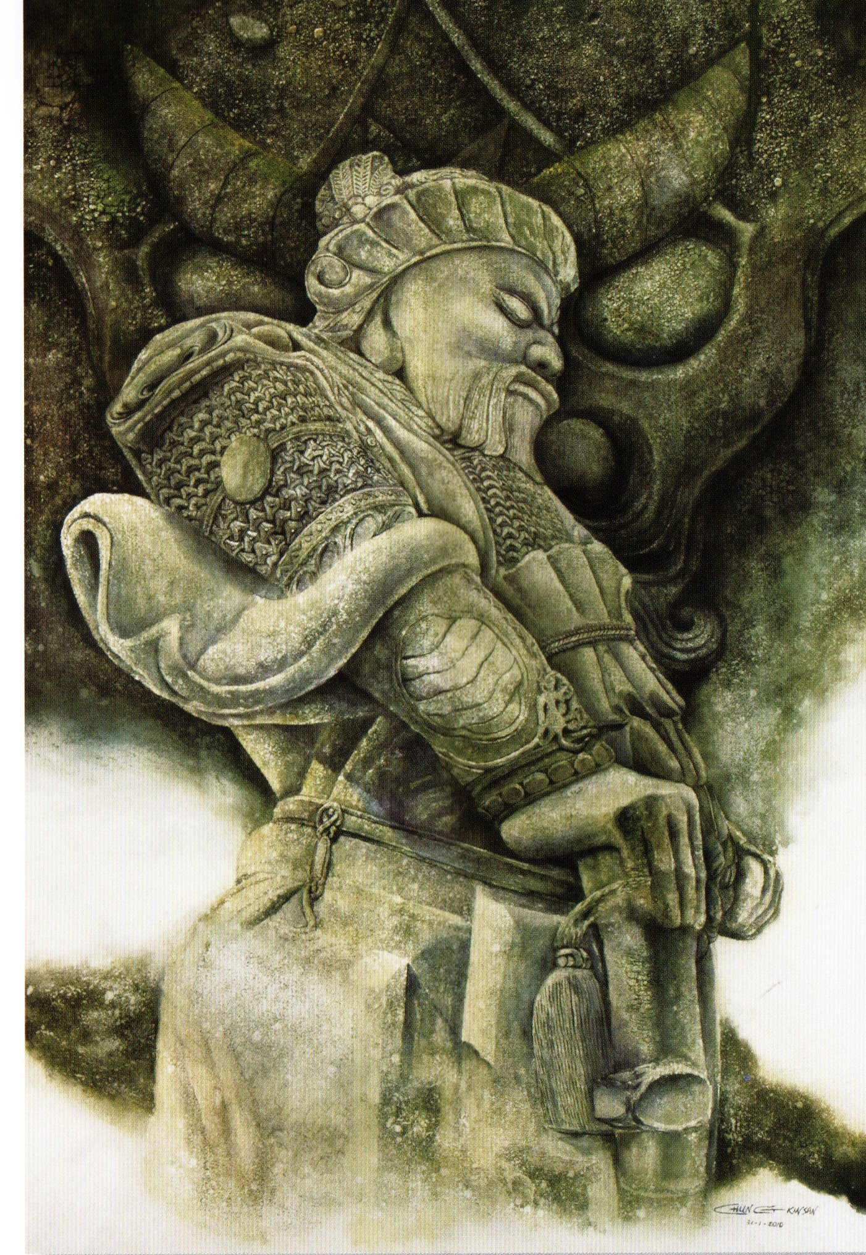
"God of Heaven", 152 x 102 cm, Watercolour on Paper

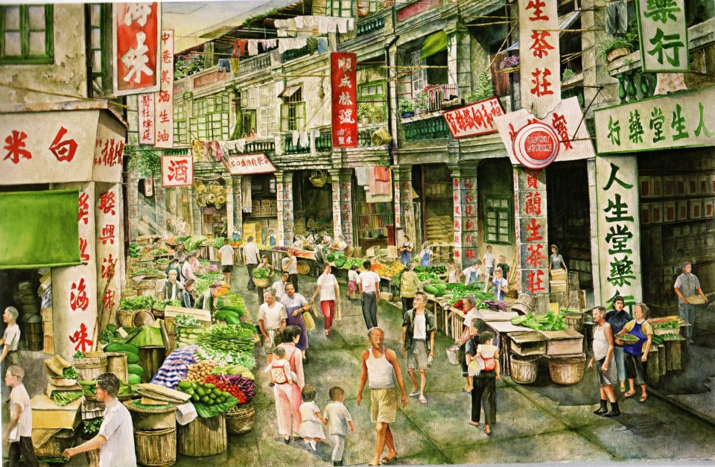
"Yau Ma Tei", 102 x 152 cm, Watercolour on Paper

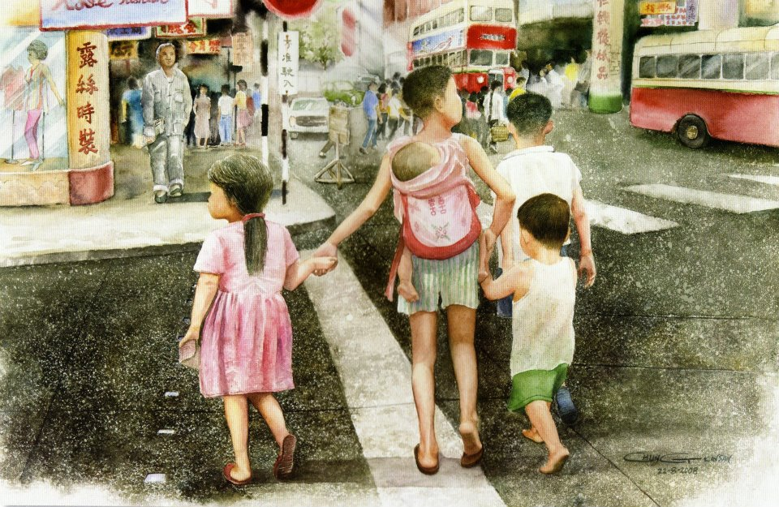
"Good Brothers", 50 x 76 cm, Watercolour on Paper

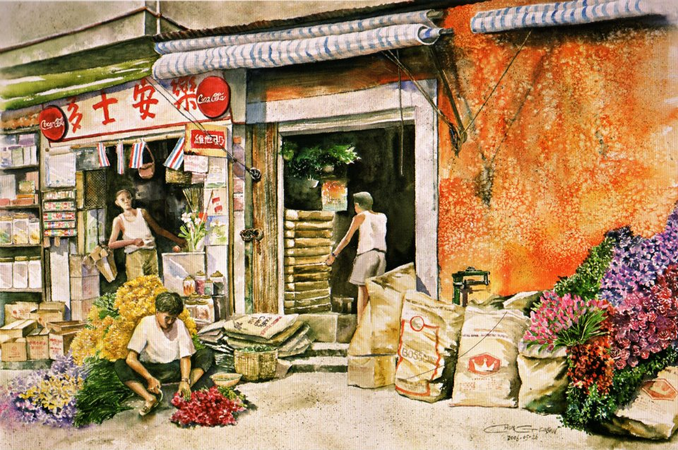
"Beautiful World", 50 x 76 cm, Watercolour on Paper

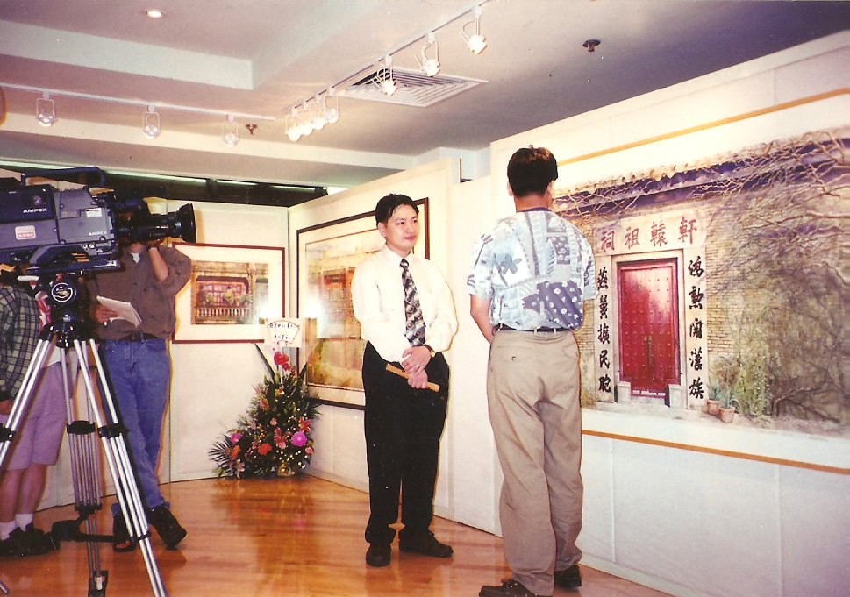
Kinsan Chung was interviewed by RTHK

